Written by :  Olivier Le Bozec | Viewed by :  Yannick Petitbois | Approved by :  Thierry Garnier

TKUI

- - - - -

TDAL

Module CRYPTO API implementation

Version V0.2

Evolutions
Version | Date | Nature
0.1 | 23/08/2004 | Initial Version
0.2 | 23/08/2004 | Editorial revision

TABLE OF CONTENTS
1 - introduction 4
1.1 - Reference documents 4
1.2 - Overview 4
1.3 - Definitions acronyme and abreviations 4
1.4 - General description 4
2 - API Specifications 5
2.1 - Types definitions 5
2.1.1 - tTDAL_CRYPT_Error 5
2.2 - TDAL_CRYPT_HashStart 6
2.3 - TDAL_CRYPT_HashContinue 6
2.4 - TDAL_CRYPT_HashTerminate 6
2.5 - TDAL_CRYPT_Compute 7
3 - STATIC behaviour 9
4 - dynamic behaviour 10
5 - DAL API IMPLEMENTATION on hpi 11
5.1 - General description 11
5.2 - Limitations 11
5.3 - Memory report 11
5.4 - Functions 12
6 - ANNEX1 : DAL CRYPT H file 13

introduction

Reference documents
 | Ref. | Ver. | Title

Overview
This document describes the implementation of the public interface for the Crypto module.
This module provides the following features:
- Hash and digest generation (MD5 available),
- Asymmetrical Signature (RSA signature/de-signature with different key sizes - usually 128 bytes - available).

Definitions acronyme and abreviations

API | Application Programmer Interface
RTOS | Real Time Operating System
TDAL | Teamlog Driver Abstraction Layer

General description
The Crypto module API is described below :
Part | Function API
Initialization of hash process | TDAL_CRYPT_HashStart
Hash process | TDAL_CRYPT_HashContinue
Termination of hash process | TDAL_CRYPT_HashTerminate
Signature | TDAL_CRYPT_Compute

API Specifications

Types definitions

tTDAL_CRYPT_Error
typedef enum
{
eTDAL_CRYPT_NO_ERROR = 0,
eTDAL_CRYPT_BAD_PARAMETER,
eTDAL_CRYPT_ERROR
} tTDAL_CRYPT_Error;

Return value for all TDAL API functions.

TDAL_CRYPT_HashStart
Prototype
tTDAL_CRYPT_Error TDAL_CRYPT_HashStart (void);
Parameters
Return value
- eTDAL_CRYPT_NO_ERROR: All cases.
Description
- Initialize the Hash processing.

TDAL_CRYPT_HashContinue
Prototype
tTDAL_CRYPT_Error TDAL_CRYPT_HashContinue ( uint8_t *pbuffer,
uint32_t len);
Parameters
Parameter | Type | Description
pbuffer | Uint8_t | Buffer to sign
len | Uint32_t | Size of the data to sign

Return value
- eTDAL_CRYPT_NO_ERROR: All cases.
Description
- Calculate the digest of the buffer. Can be called as many times as needed.

TDAL_CRYPT_HashTerminate
Prototype
tTDAL_CRYPT_Error TDAL_CRYPT_HashTerminate ( uint8_t *pDigest,
uint16_t DigestLen);
Parameters
Parameter | Type | Description
pDigest | Uint8_t | Buffer filled with the signature
StreamType | Uint16_t | Size of the signature

Return value
- eTDAL_CRYPT_BAD_PARAMETER : The hash size is not handled.
- eTDAL_CRYPT_NO_ERROR : All other cases.
Description
- Return the digest of data between the first call to TDAL_CRYPT_HashContinue() after an TDAL_CRYPT_HashStart() and the last previous call to TDAL_CRYPT_HashContinue().
The length of the digest depends of the used algorithm.

TDAL_CRYPT_Compute
Prototype
tTDAL_CRYPT_Error TDAL_CRYPT_Compute ( uint8_t *pKey, uint16_t Keylength,
uint8_t *pDigest, uint16_t DigLen,
uint8_t *pResult);

Parameters
Parameter | Type | Description
pKey | uint8_t * | Buffer that contains the private or the public key.
Keylength | uint16_t | Key size in bytes.
pDigest | uint8_t * | Buffer that contains data to crypt or to decrypt.
DigLen | uint16_t | Size of crypt data in bytes. Must be equal to the size of the key.
pResult | uint8_t * | Result of pDigest uncrypted or crypted.

Return value
- eTDAL_CRYPT_ERROR : Underlying layer error.
- eTDAL_CRYPT_NO_ERROR: All other cases.
Description
- Sign or design a buffer using a private or a public key of asymmetrical algorithm. The length of the key depends of the used algorithm.

STATIC behaviour

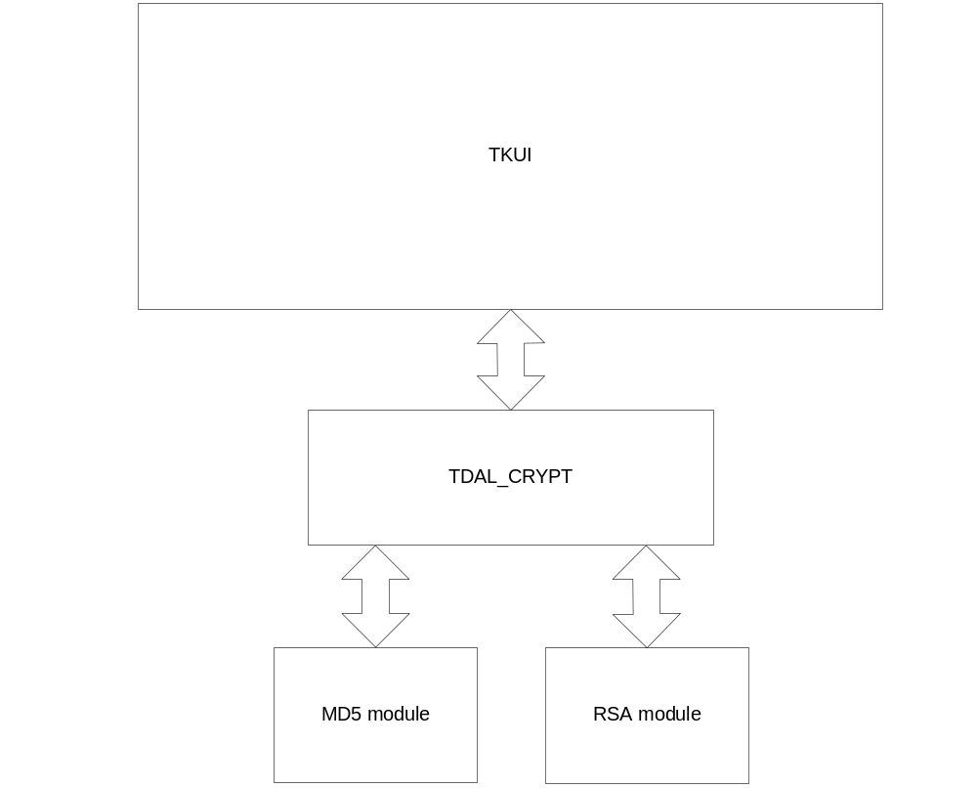

dynamic behaviour

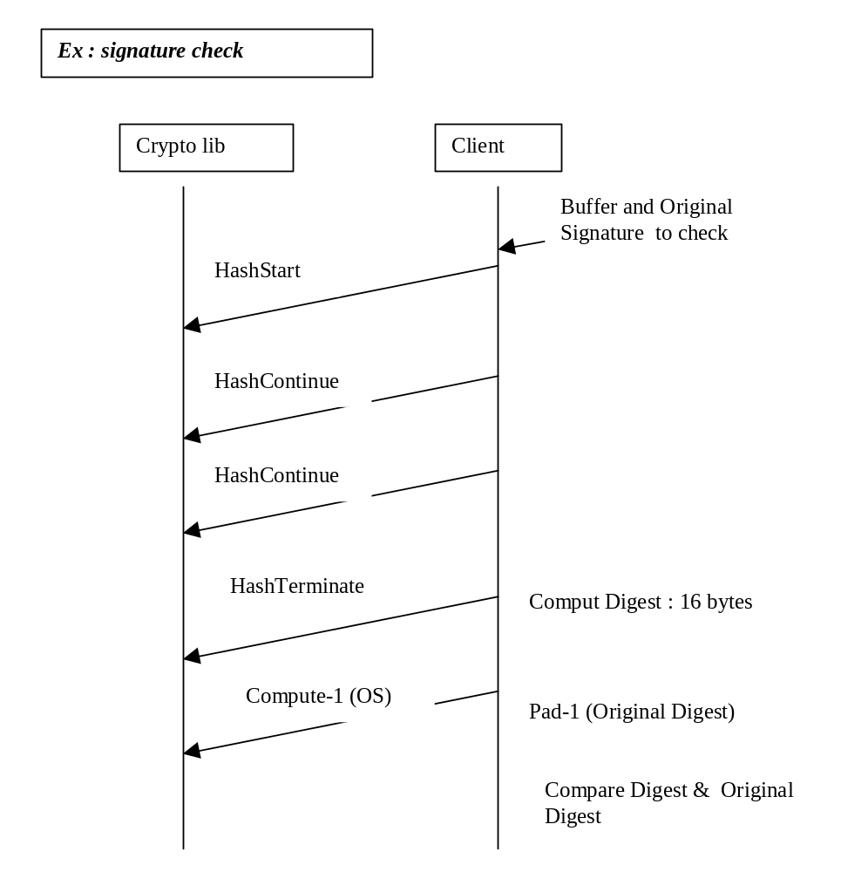

DAL API IMPLEMENTATION on hpi

General description
There is no task for this implementation neither any OS objects.
The Hash algorithm is MD5. The length of the MD5 digest is 16 bytes.
The signature algorithm is RSA. The length of the RSA key is variable.

Limitations
- Only MD5 hash is implemented.
- Only RSA is implemented.
- The padding algorithm between the digest length and the RSA buffer length is not perform by these function. The client must use some padding algorithm such as PKCS1-v1_5.

Memory report
- The stack size of the task calling TDAL_CRYPT_Compute() must be enough to handle multiple recursive function call.

Functions

All functions are mapped on MD5 or RSA libs provided by CryptoTec for CyptoWork.

Public Key format : First byte to 0 then the key. By default Exp = 65535.

uint8_t LOAL_CRYPT_RsaPublicKey[] = {

0x00

, 0xBF, 0x7F, 0x17, 0xA2, 0x19, 0x9A, 0x13, 0x5D, 0x0D, 0x4A, 0x0B, 0xA0, 0x60, 0xF8, 0xAD, 0x84

, 0x3E, 0x73, 0x27, 0xF5, 0x44, 0xF1, 0x5F, 0x14, 0xDB, 0x25, 0xB9, 0x8E, 0xEE, 0xD6, 0x8A, 0x0B

, 0xDA, 0x92, 0xE6, 0xF5, 0xB2, 0x07, 0x2F, 0xC4, 0x8B, 0x29, 0xB7, 0x1E, 0xA4, 0x97, 0xA6, 0xE0

, 0xD2, 0xDE, 0x03, 0x51, 0xD6, 0xA1, 0x00, 0x9A, 0x23, 0x7B, 0x71, 0xB2, 0x6E, 0xFE, 0x55, 0x18

, 0x1C, 0x63, 0xC3, 0x08, 0xDE, 0xA6, 0xC1, 0xB0, 0x75, 0x53, 0x27, 0xA1, 0x56, 0xB8, 0x59, 0x38

, 0xD6, 0x4E, 0x10, 0x5C, 0x97, 0x9B, 0xEC, 0x0D, 0xA7, 0x15, 0x6E, 0xF8, 0x70, 0x75, 0x0B, 0xD7

, 0x5F, 0x5D, 0xF4, 0xF7, 0x77, 0x79, 0x1C, 0x8B, 0x9E, 0x73, 0x71, 0x58, 0xAA, 0xFD, 0x7E, 0xB0

, 0x12, 0xF2, 0x36, 0x99, 0xF4, 0x8F, 0x70, 0x9E, 0x45, 0x0C, 0xCD, 0x9F, 0x25, 0xD9, 0xCF, 0xFB

};

ANNEX1 : DAL CRYPT H file
/******************************************************************************
* COPYRIGHT 2004 TEAMLOG DMS *
******************************************************************************
*
* MODULE NAME: TDAL_CRYP
*
* FILE NAME: $Workfile : tdal_crypt.h $
* $Revision : 1.0 $
* $Date : 16 july 2004 $
*
* Description : Cryptography TDAL implementation
* Target : All
* Author :
* Date of creation : 16 / 07 / 2004.
*
*****************************************************************************/

#ifndef _TDAL_CRYPT_H_
#define _TDAL_CRYPT_H_

/*--------------------------*/
/* Header needed. */
/*--------------------------*/

#ifdef __cplusplus
extern "C" {
#endif

/*------------------------------------------*/
/* Public types definition */
/*------------------------------------------*/

typedef enum
{
eTDAL_CRYPT_NO_ERROR = 0,
eTDAL_CRYPT_BAD_PARAMETER,
eTDAL_CRYPT_ERROR
} tTDAL_CRYPT_Error;

/*------------------------------------------*/
/* Public Functions Declarations */
/*------------------------------------------*/
tTDAL_CRYPT_Error TDAL_CRYPT_HashStart (void);
tTDAL_CRYPT_Error TDAL_CRYPT_HashContinue (uint8_t *pbuffer, uint32_t len);
tTDAL_CRYPT_Error TDAL_CRYPT_HashTerminate (uint8_t *pDigest, uint16_t DigestLen);

tTDAL_CRYPT_Error TDAL_CRYPT_Compute (uint8_t *pKey, uint16_t Keylength, uint8_t *pDigest, uint16_t DigestLen, uint8_t *pSignature);

#ifdef __cplusplus
}
#endif

#endif /*_TDAL_CRYPT_H_*/

